Week 4
5. JWT-hands-on
Create authentication service that returns JWT

com.cognizant.spring_learn.config
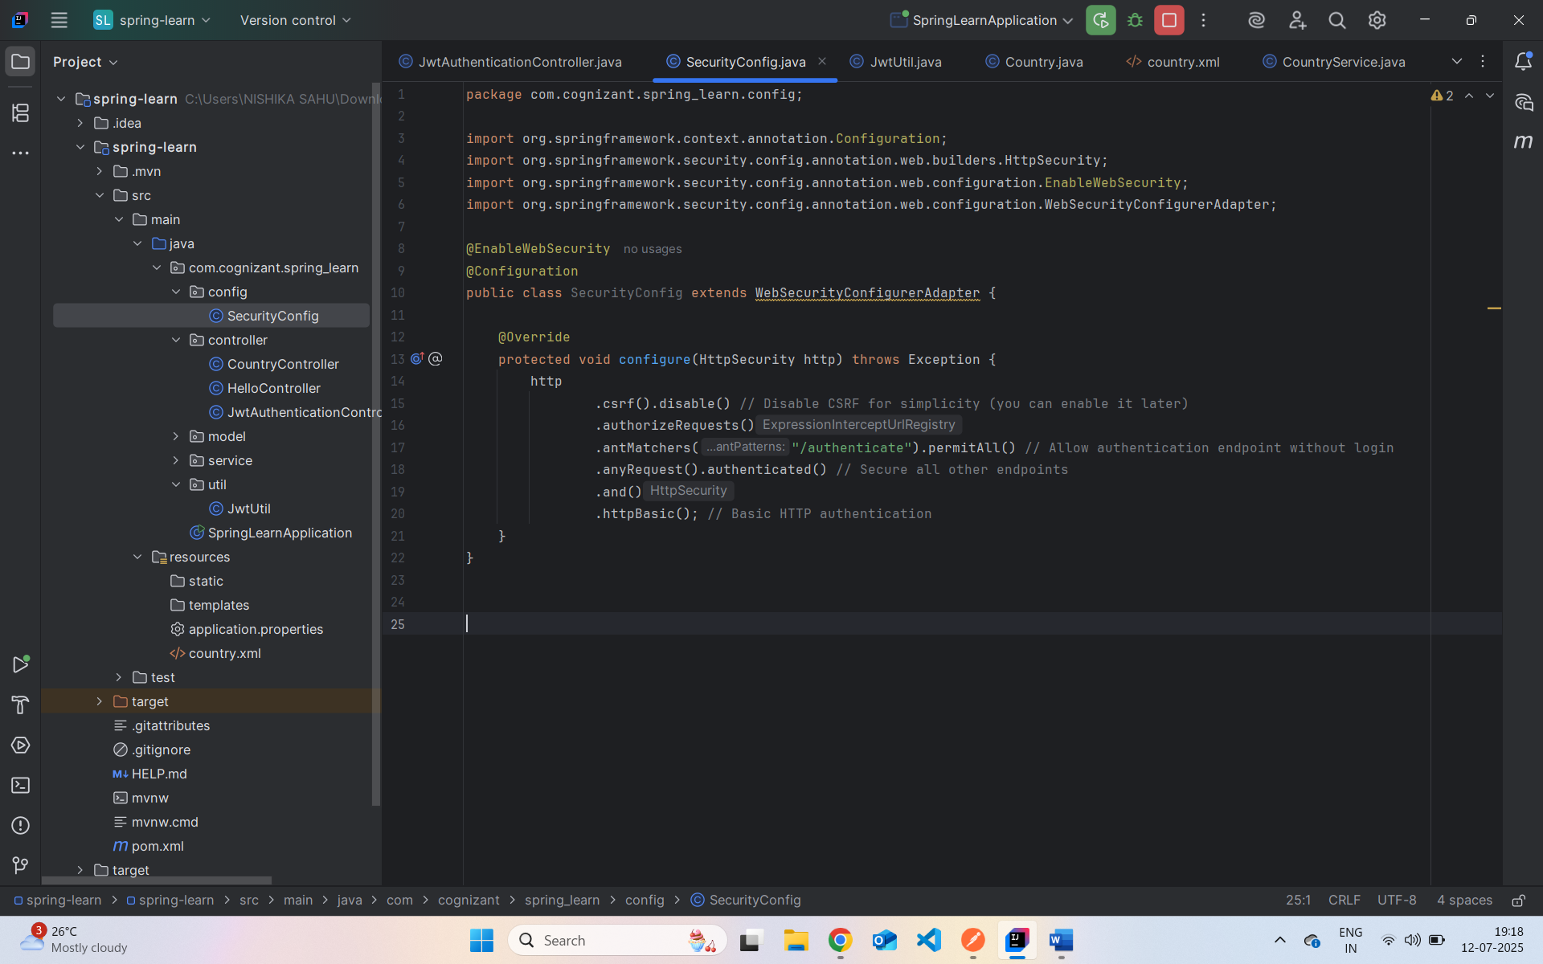

com.cognizant.spring_learn.controller
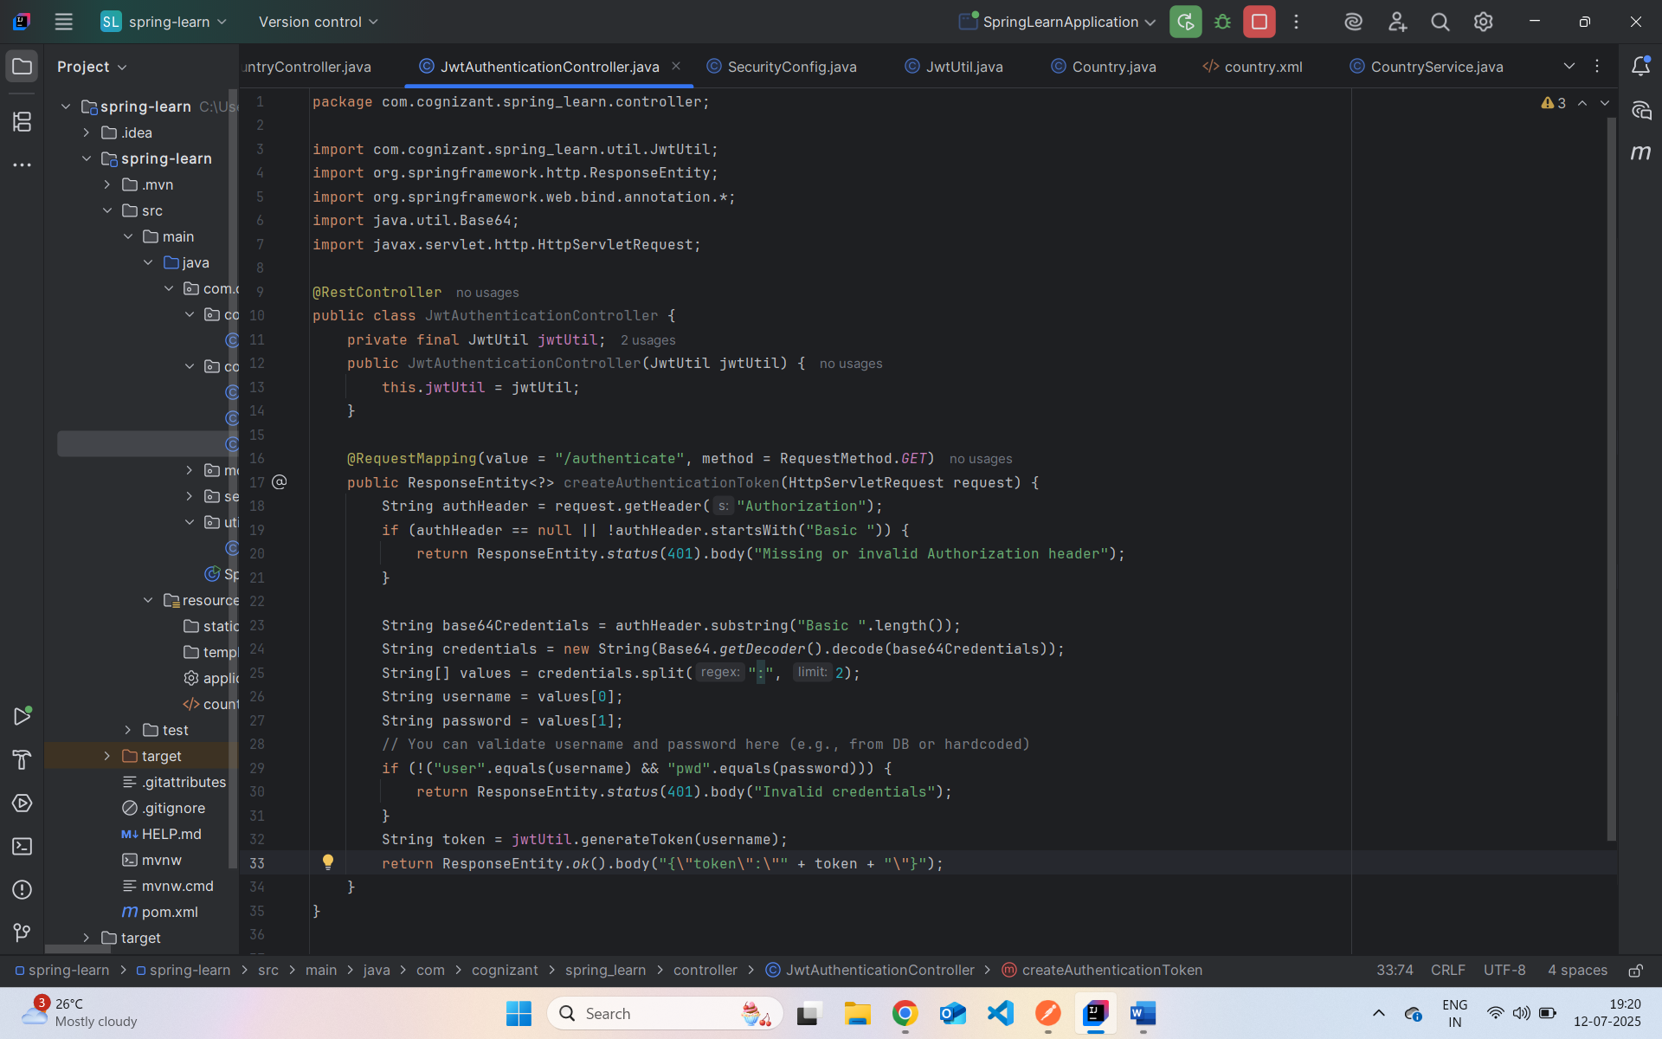

com.cognizant.spring_learn.util
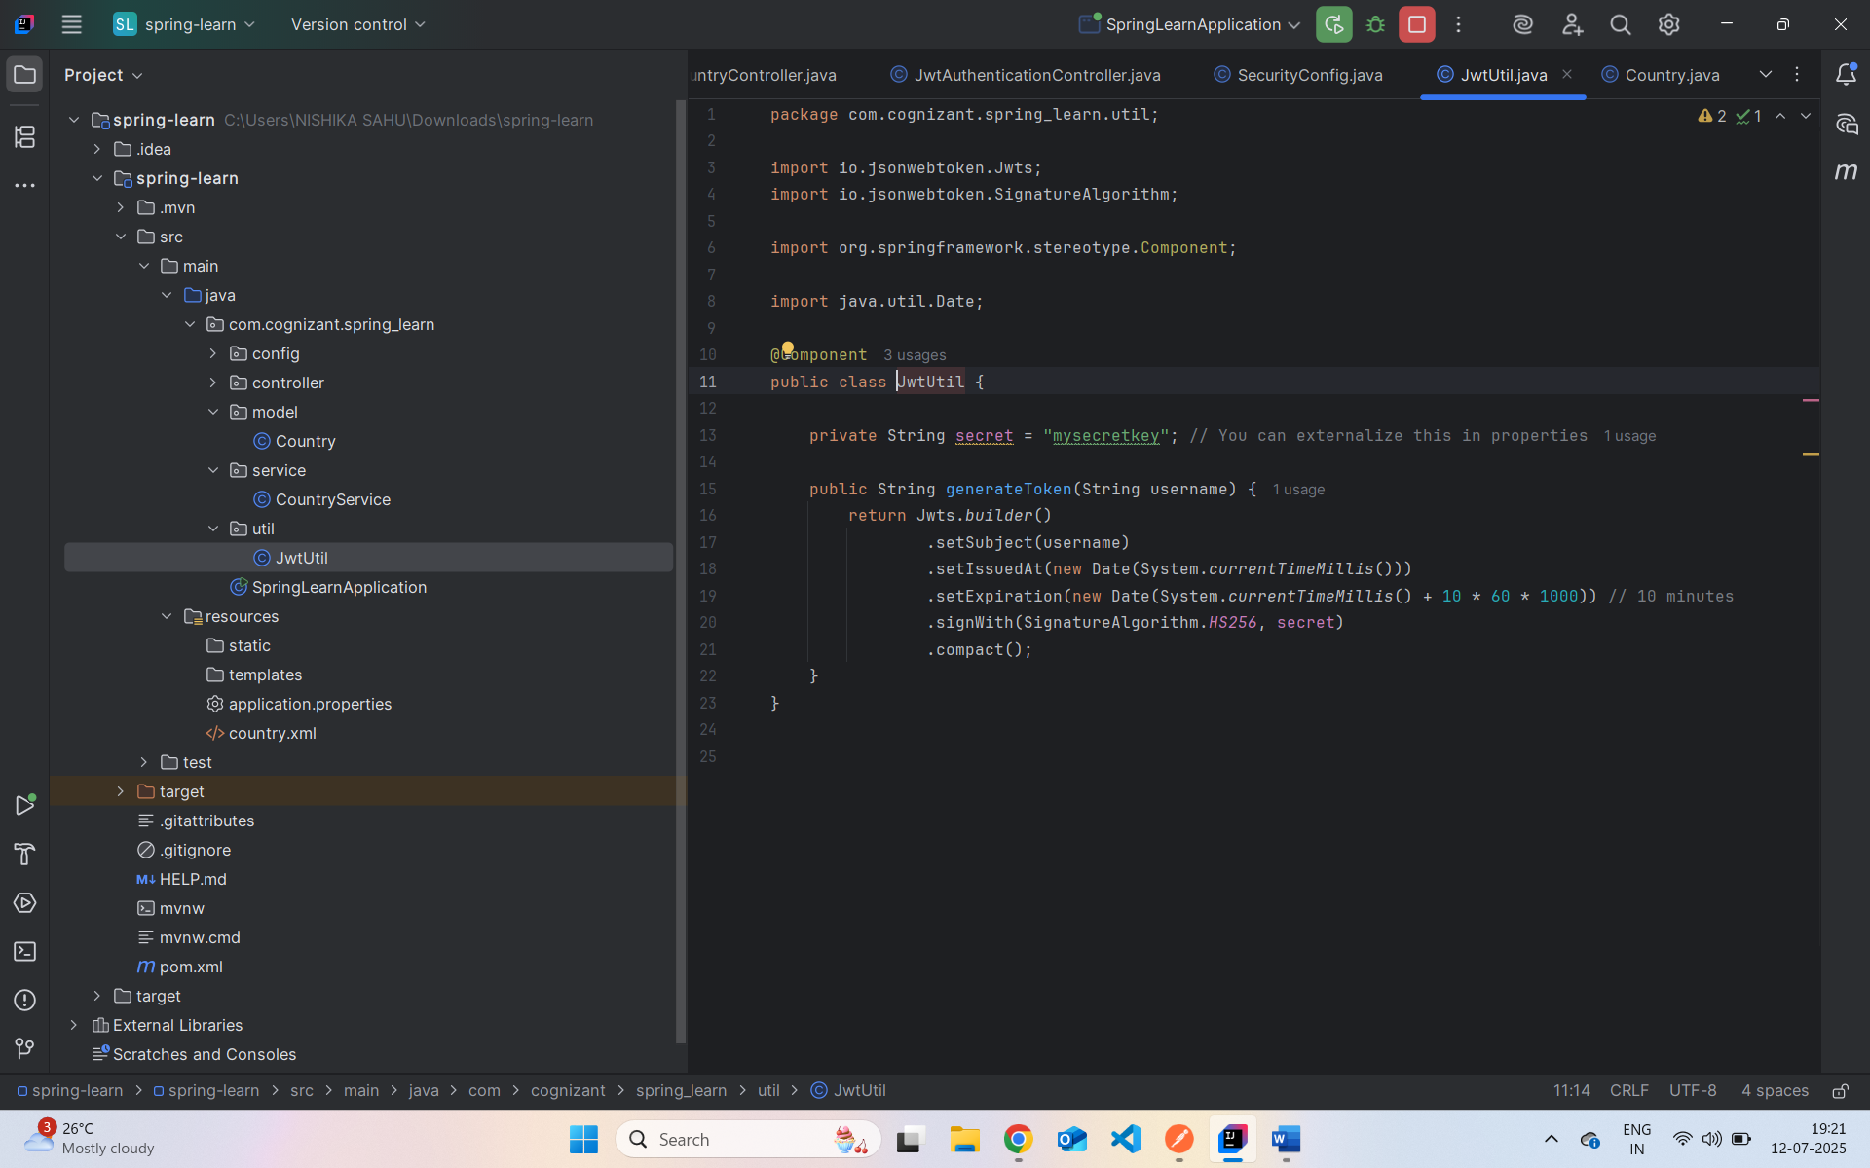
Application.properties
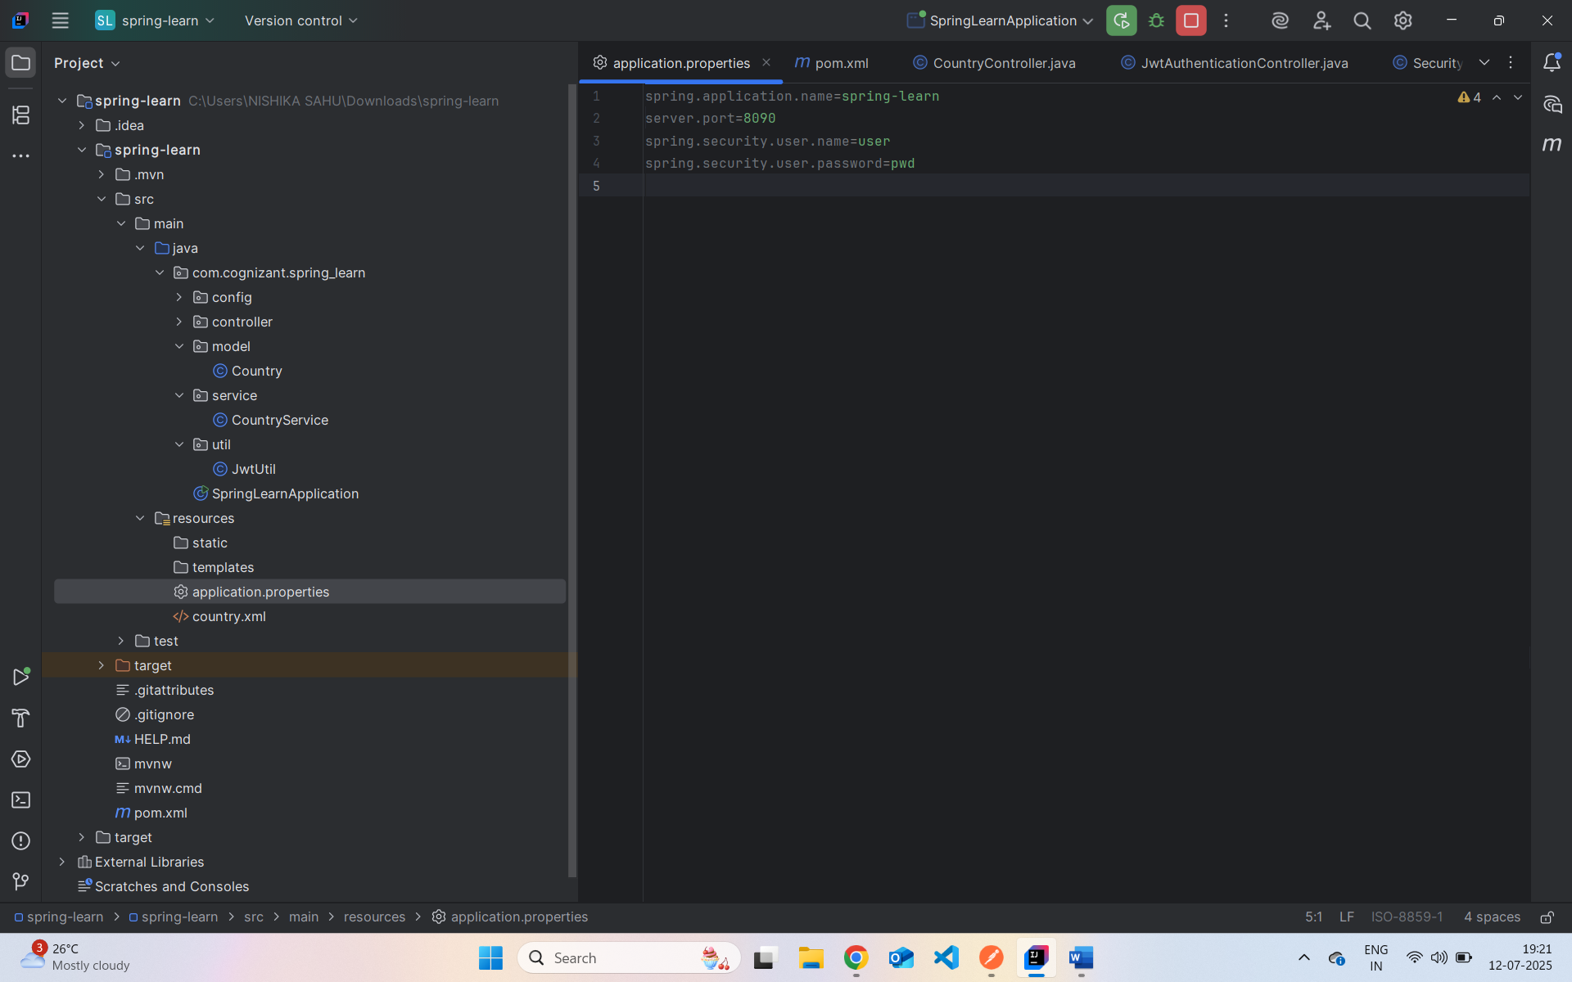
Output In PostMan:
